CSD 330 – Security Analytics

Bid #1

Kabir Kanha Arora

Topic: Detection of Child Predators/Cyber Harassers on Social Media
(Type 1 – Self Chosen)
Idea
This idea is born out of a pressing need to curb a growing problem. Even the best of things come with their pitfalls. Growing technology and connectivity have led to an increased number of child predators and cyber stalkers online. My solution aims to efficiently nip this problem in the bud using advanced Machine Learning techniques such as Support Vector Machines (SVM), Decision Trees, K-Nearest Neighbours and Random Forests.
Technology Stack
- Python
- Scikit-Learn
- NLTK
- Pandas
- MATLAB
- Keras
Use Cases
The use cases for this problem are virtually unlimited. Users on almost all social media websites and discussion forums can fall prey to such predators. This tool will be prototyped on a particular platform and then generalized to suit the requirements of all such platforms, thereby leaving a huge population much safer than they were before. Any website can use this tool to flag suspicious profiles and become a much better space for all its users.
Unique Selling Point (USP)
Through the project, I highlight key concerns of cyber harassment stemming from the use of digital media and discusses existing models of face-to-face bullying which may aid in modelling cyberbullying. I then introduce state-of-the-art research in automated tools to detect cyber harassment. As of now, not much work has been done in this field and also suffers from a severe lack of precision and efficiency. I aim to iron out these flaws and present a novel approach to this age-old problem
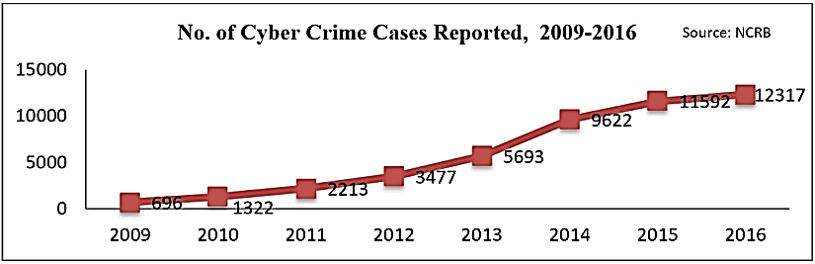
Why?
- Majority of children around the globe are bullied online in some form or the other.
- Cyberbullying poses significant threat to physical and mental health of the victims.
- Unlike other criminals, cyber bullies can hide behind a mask of anonymity online, and do not need direct physical access to their victims to do unimaginable harm.
- This tool is a step towards making the cyber-space safer for everyone especially people under the age of 18.
What?
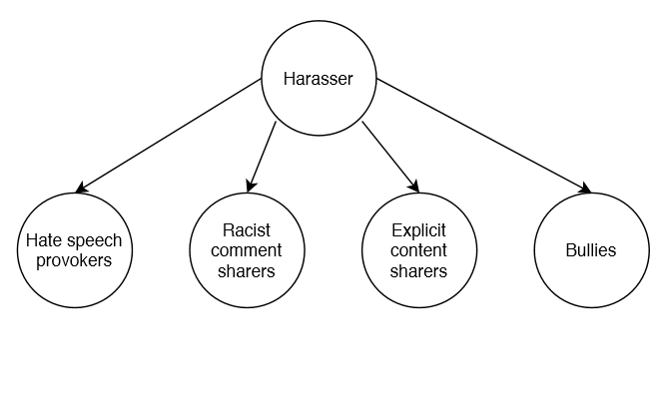
- I can work under the assumption that people who are likely to be cyber harassers show either one or more of these behaviors towards minors in the cyber space.
- If I can identify the people who send such content out, I can find out who is a threat to others on the internet.

Literature Review
- Escalante, Hugo Jair et al. “Sexual predator detection in chats with chained classifiers.” WASSA@NAACL-HLT (2013).
  - Describes a novel approach for sexual predator detection in chat conversations based on sequences of classifiers.
  - The proposed approach divides documents into three parts, which correspond to the different stages that a predator employs when approaching a child.
  - Local classifiers are trained for each part of the documents and their outputs are combined by a chain strategy.
  - Proposed a ring-based strategy, in which the chaining process is iterated several times, with the goal of further improving the performance of their method.
- Miah, Md. Waliur Rahman et al. “Detection of child exploiting chats from a mixed chat dataset as a text classification task.” ALTA (2011).
  - The paper investigated the effectiveness of text classifiers to identify Child Exploitation (CE) in chatting.
  - Along with three traditional text categorizing techniques a new approach was made to accomplish the task.
  - Psychometric and categorical information by LIWC (Linguistic Inquiry and Word Count) was used and improvement of performance in some classifier was found.
  - Classification-via-Regression, J-48-Decision-Tree and Naïve-Bayes classifiers are used.
- Nandhini, B. Sri and J. I. Sheeba. “Online Social Network Bullying Detection Using Intelligence Techniques.” (2015).
  - The proposed method was an effective method to detect cyberbullying activities on social media.
  - The detection method can identify the presence of cyberbullying terms and classify cyberbullying activities in social network such as Flaming, Harassment, Racism and Terrorism, using Fuzzy logic and Genetic algorithm.
  - The effectiveness of the system was increased using Fuzzy rule set to retrieve relevant data for classification from the input.
  - In the proposed method Genetic algorithm was also used, for optimizing the parameters and to obtain precise output.

- Huang, Qianjia et al. “Cyber Bullying Detection Using Social and Textual Analysis.” SAM@MM (2014).
  - Aim was to find out if analyzing the social network features can improve the accuracy of cyber bullying detection.
  - By analyzing the social network structure between users and deriving features such as number of friends, network embeddedness, and relationship centrality, I found that the detection of cyber bullying can be significantly improved by integrating the textual features with social network features.
Existing Tools and The Need to Improve
- Cyber harassment can be tracked using online available applications and tools. eBlaster, Net Nanny, cloud9 and IamBigBrother are some available commercial tools available to protect children from Internet predators.
- They work based on Packet sniffing. These tools scan all the outgoing and ingoing traffic in a network and then apply a filter. But the problem with these tools is that they are based on a simple keyword matching and hence its accuracy is questioned.
Proposed Solution
- I propose to make a tool that can be deployed by anyone who wishes to monitor the users of their website in order to identify cyber criminals.
- The tool will focus on classifying all the users as suspects or non-suspects based on their activities. This classification, though has existing algorithms, isn’t done veRy efficiently in today’s day and age.
- I strive to have a high accuracy, precision and recall in order to create an environment that is safer for the children in the cyber space.
- This tool revolutionizes the way automated identification of suspects happens in the world currently.
Relevant Datasets
- Datasets of text conversations on social media
- Datasets on information related to search history and visited pages.
- Datasets on user activity.
- Datasets on user demographics.
High-Level Solution
- I propose to make a tool that can be deployed by anyone who wishes to monitor the users of their website inn order to identify cyber harassers and child predators.
- The tool will focus on classifying all the users as suspects or non-suspects based on their activities. THIS classification, though has existing algorithms, isn’t done very efficiently in today’s day and age.
- I strive to have a high accuracy, precision and recall in order to create a SAFER CYBER SPACE. This tool revolutionizes the way automated identification of cyber criminals happens in the world currently.
- The proposed tool focuses on higher precision and recall rather than simply taking a gander at the accuracy itself. This is done on the grounds that I would prefer not to let any "bad" USER escape without being apprehended and on the same hand I don't wish to flag any "good" USER incorrectly.
- Keeping this in mind, I aim to use a one-of-a-kind multi-LAYER classification algorithm thereBY ensuring that no profile is flagged erroneously in light of their interactions with any other client in a "warm" manner.

Approach
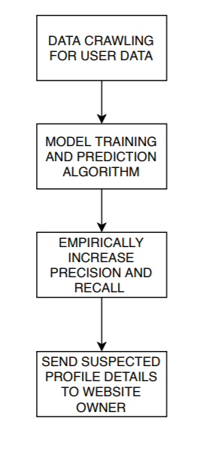
- To be able to build representative models for cyber bullying, a suitable dataset is required. For this purpose, I construct a corpus containing user’s social media posts and metadata and manually annotate it for cyber harassment.
- This is followed by pre-processing, for which I will apply tokenisation, PoS-tagging and lemmatisation to the data.
- After performing pre-processing on the input data, it is given to Feature extraction to obtain features like Noun, Adjective and Pronoun from the text and statistics on word frequency in the text.
- The extracted features are fed into the learning algorithm which is a genetic algorithm to model adaptive and exploratory behaviour. Knowledge is given as a fuzzy rule set. The output is classified bullying words present in the text.
- Now the users’s profile data is checked for the presence of these bullying words above a experimentally obtained threshold value to determine if he user is a cyber crime suspect or not using various machine learning models like K- nearest, SVM, Decision trees and Random forests.
- The suspect profiles are now kept on surveillance. The occurrence of related cyber bullying activities by the users of these profiles causes them to be labelled as ‘harassers’.
- In the final phase, the profiles labelled as harassers undergo sentiment and polarity analysis to determine the psychological effects of their activities so that the instances of extremely negative polarity could be blocked immediately while the others could be reported to the site owner.
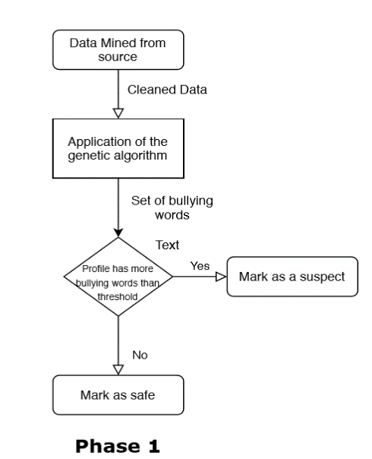
Proposed Algorithm
- Input given in the form of text conversations is pre-processed first and then cleaned.
- Cleaned data is forwarded for feature extraction
- Extracted features are fed to the learning algorithm- Genetic algorithm
- Algorithm works on the knowledge base of Fuzzy rules set
- Chromosomes compete to predict the classification of bullying activities
- Output fed to classifier to classify based on fitness value of the chromosome
- Output of the algorithm is a set of classified bullying words.
- This set of words is used to determine if a profile user is a cyber crime suspect or not.
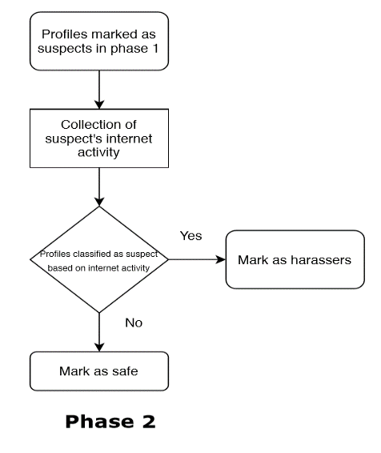

- Once the profiles are marked as “suspects”, they are then cross verified using machine learning techniques.
- My unique tool employs not one but 4 different machine learning models to get better results.
- The four models have been chosen after extensive literature review.
- The suspects’ internet usage is monitored. Special attention is paid to his/her posts, comments, messages and search histories.
- Based on these parameters, they are further classified as suspects or non-suspects.

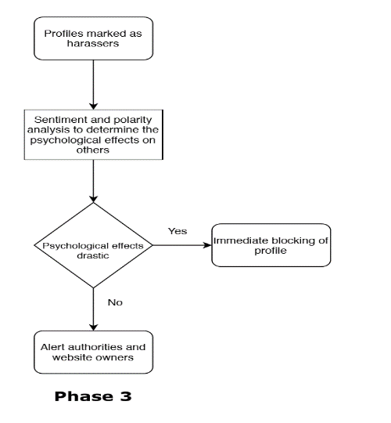
- Sentiment analysis is contextual mining of text which identifies and extracts subjective information in source material, and helping a business to understand the social sentiment of their brand, product or service while monitoring online conversations.
- It refers to the use of natural language processing, text analysis, computational linguistics, and biometrics to systematically identify, extract, quantify, and study affective states and subjective information.

Machine Learning Model Used
- Support Vector Machines (Supervised)
  - A discriminative classifier formally defined by a separating hyperplane.
  - In two-dimension space, this hyperplane is a line dividing a plane into two parts dividing the datapoints into two classes.
  - Similarly, can be expanded for higher dimensions.
  - Example-pictorial representation of separating rabbits and tigers by making fence between them.
- Decision Trees (Semi-Supervised)
  - A decision supporting tool that uses a tree-like graph or model of decision and their possible consequences.
  - A flow chart-like structure in which each internal node represents a “test” on an attribute
  - Each branch represents the outcome of the test, each leaf node represents class label.
  - Path from root to leaf represents classification rules
  - Example- temperature prediction model
- Random Forest (Supervised)
  - Random forest is a divide-and-conquer approach used to improve performance.
  - Can be thought of as a form of nearest neighbor predictor.
  - The result may either be an average or the weighted average of all of the terminal nodes that are reached.
  - Runtime is quite fast
  - Able to deal with unbalanced and missing data
- K-Nearest Neighbours (Supervised)
  - A non-parametric classification and regression technique.
  - Input dataset add any unknown value, and algorithm will tell which class that unknown datapoint belongs to.
  - The unknown point is classified by simple neighbour voting and class of close neighbours win.

Market Analysis
- There are no such tools that are available at a commercial level
- Tools like Net Nanny, IamBigBrother and eBlaster mentioned in earlier slides allow monitoring of systems remotely as well as imposing certain restrictions and aim to provide protection through either blocking access to certain types of sites completely or by detection of certain keywords in messages exchanged
- My tool aims to provide a higher level of protection by going through comments and monitoring user activity to detect for the slightest hint of suspicious behaviour

